The Superior University
AI Lab Tasks
Lab 03

Artificial Intelligence (Lab)
Mr. Rasikh Ali
Name: Afaq Akhtar
Roll No:SU92-BSSEM-S25-060


Task 1: BFS and DFS Implementation & Trace
Breadth-First Search (BFS):Uses a Queue data structure following the FIFO (First In, First Out) principle.Explores the graph level by level, visiting all the neighbors of a node before moving to the next level.
Depth-First Search (DFS):Uses a Stack data structure following the LIFO (Last In, First Out) principle.Explores the graph by going as deep as possible along each branch before backtracking.
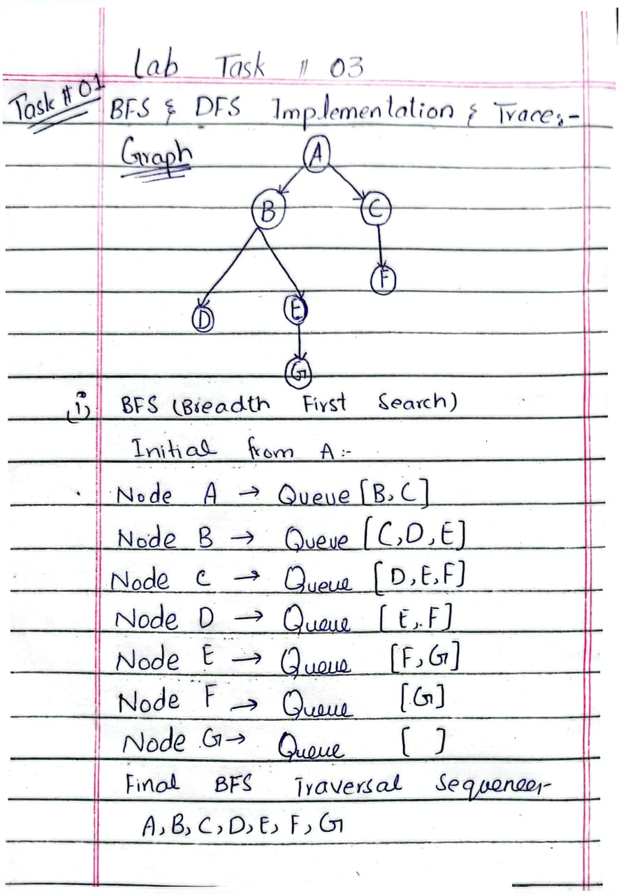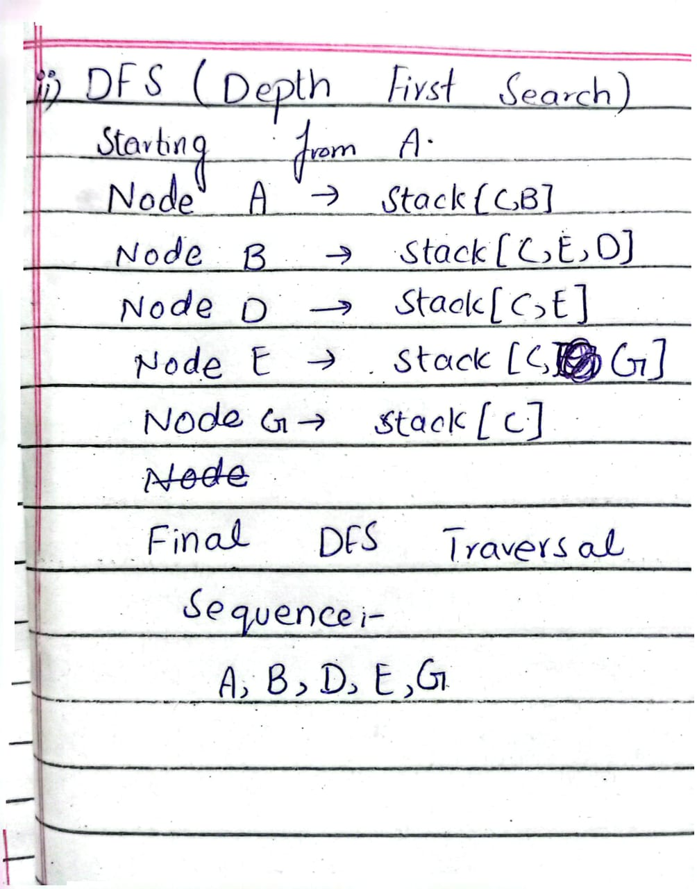

Program Implemantation is in attached file named with bfs & dfs.py
Output Explaination:
The program prints two lists at each step: the first list is the frontier (queue in BFS, stack in DFS) and the second list is the visited list.
In BFS, the queue starts from [A] and grows step by step, and nodes are processed level by level.
The final BFS visited order is A, B, C, D, E, F, G, and at the end the queue becomes empty, which means all nodes are processed.
In DFS, the stack starts from [A] and the search goes deep along one branch: A, then B, then D, then E, then G.
The final DFS visited order is A, B, D, E, G.
The DFS stops as soon as G is processed, so C is left in the stack and F is never visited.
The final path is the same for both algorithms: A → B → E → G.
Task 2: Depth-Limited Search (DLS)
Code Implementation is in attached file named with dls.py

Results & Analysis
Limit 1:CUTOFF(The goal G is at depth 3, so a limit of 1 cannot reach it).
Limit 2:CUTOFF (Still insufficient depth to reach G).
Limit 3:FOUND (Path:A,B,E,G successfully found since the goal lies at depth 3).
Limit 4:FOUND (Path:A,B,E,G found within the permitted limit).

